TENSIONER
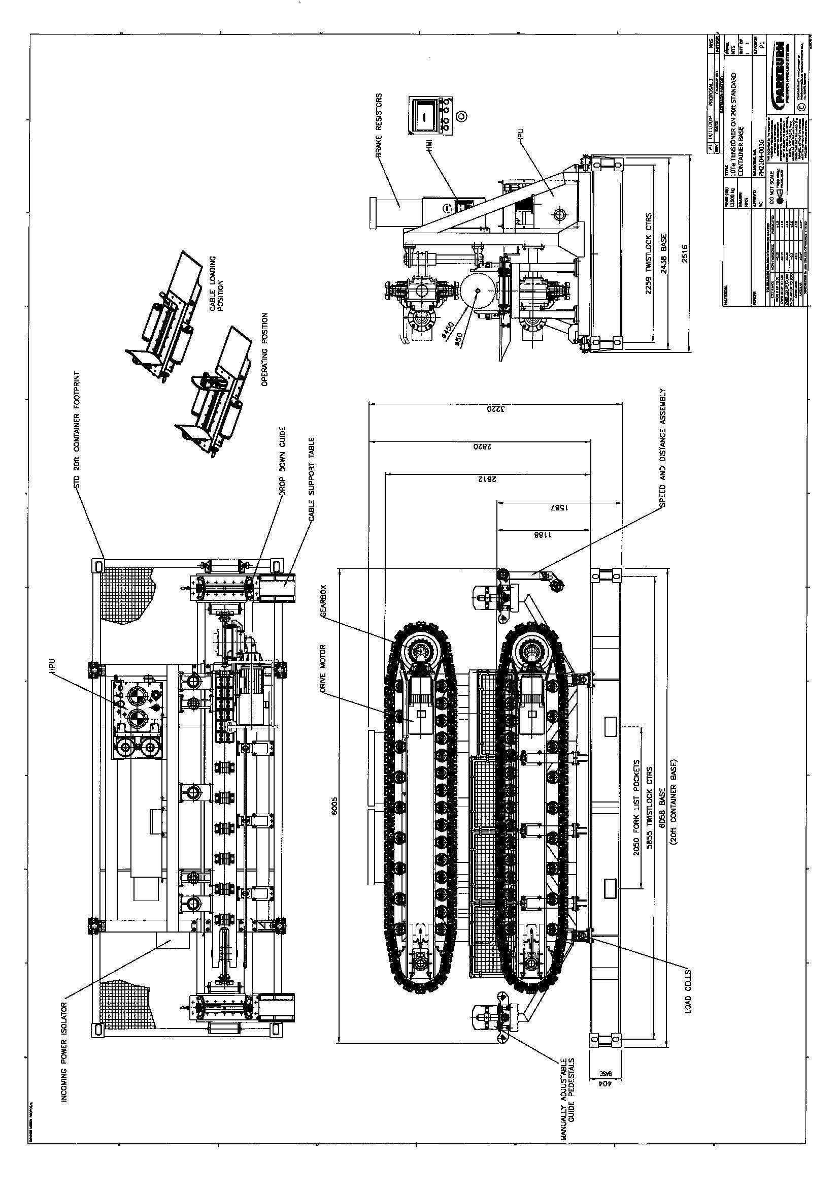

TECHNICAL SPECIFICATION

AC Electric Tensioner General Description
The following 1 x 10 Te self-contained (“plug and play”) side loading AC electric 2-track tensioner complete with the following benefits & features:
- 400 V/50 Hz AC electric drive for smooth & stepless operation
- No external cooling required from vessel
- Digital motor / track / machine to machine speed synchronisation*
- Integral & independent dual redundant speed and distance system
- Integral load cell and pitch compensated tension control system
- Integral hydraulic supply for track open/close, track squeeze and brakes (using bio degradable oil)
- System alarms and instrumentation provided on tensioner mounted HMI display & remote control console
- Back up tensioner control via hardwired local control pendant.
- Hydraulic manifold / valve block housed with a stainless steel enclosure
- Drive panels to be painted stainless steel with sealed-air marine air conditioning units
- Resistor banks to be “run quiet” natural self-cooled units
- Designed and manufactured in accordance with IP56 (minimum) ingress protection levels
*Speed synchronisation with other manufacturers equipment is subject to the 3rd party equipment’s capability.

10Te Tracked Tensioner Specification Table
Item | Design Element | Specification / Description
1 | Max Tension* | 10 Te (in either direction)
2 | Performance | 0-17 m /min
3 | Product Ø Range | From approx. 50 mm to 450 mm
4 | Max Opening | Approx. 500 mm
5 | Max Grip Force | Approx. 110 kN/m/track adjustable from 30% to max
6 | Track Orientation | 2 track – side loading (c/w top loading side bars)
7 | Track Contact Length | Approx. 3 m
8 | Assumed Product CoF | 0.15
9 | Track Pad Type | V- grooved rubber bonded bolted pads (bolted type)
10 | Motor Type | The AC electric motors fitted will be totally enclosed, force fan cooled, foot and flange mounted, to IP 56. The motors will be supplied c/w anti condensation heaters and Class F insulation.
11 | Drive Type | Integral AC vector drives will allow the tensioner speed and / or torque to be controlled smoothly in either direction from zero to 100% and continuously be able to hold full torque at zero speed. Drive panel is painted stainless steel with sealed-air marine air conditioning unit to IP56.
12 | Gearbox Type | Flange mounted rotating case planetary type c/w coupling.
13 | Brake Type | Suitably rated spring applied hydraulic released failsafe brake (integral with gearbox assembly)
14 | Track Squeeze Pressure | Track squeeze shall be manually adjusted via a pressure valve located on the tensioner.
15 | Integral HPU | An integrally mounted HPU shall be provided to provide track squeeze, track open and close and track brake functions.  The HPU shall be rated for open deck use to a minimum of IP56 and shall be rugged and reliable in design. The HPU shall be manufactured c/w stainless a steel reservoir, pipework & stainless/zinc plated fittings
16 | Tension Measurement & Control | Integral (4 x) load cell based & pitch compensated system to allow accurate measurement of outboard tension and tension controlled operations.
17 | Speed and Distance | Via freely rotating wheel/roller and dual encoder assembly.
18 | Inboard / Outboard Cable Guides | Manually adjustable horizontally oriented roller guides shall be fitted at the product entry and exit points.
19 | Controls | Controlled via remote console or back up hardwired pendant control unit.
22 | Instrumentation | Integral HMI display on tensioner panel & remote console.
23 | Maximum Power Demand | Approx. 60 kW
24 | Weight | Approx. 11,000 KG
25 | Space Envelope | Approx. L 5,700 x W 2,550 W x H 2,850
25 | Supply Voltage | 400 V @ 50Hz
* Note to Tensioner Performance Figures
The equipment is designed to run continuously subject to the maintenance operations defined within the technical manuals. It should be noted that the stated performance with respect to tension is dependent upon the coefficient of


friction between track pad or tyre and the product being adequate, under the working conditions encountered. In the case of products of small diameter, that have low crush resistance and/or a low coefficient of friction, the equipment has to be de-rated accordingly for tension.
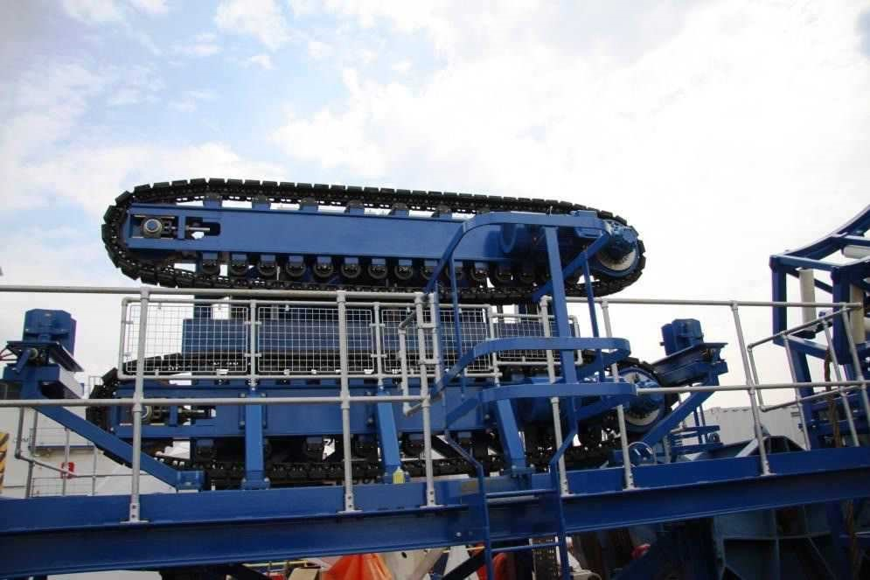
Example Aft Deck 10Te Side Loading 2 -Track Tensioner (on vessel)

Controls
Parkburn designs and manufactures the drive and control systems for its tensioners in house, so a high degree of flexibility is offered for controls hardware, software, style and layout.
For this proposal we have included a fixed position hardwired remote control console which shall incorporate all required control features and provide all required alarm and instrumentation features from an integrally fitted HMI. The tensioner shall also be fitted with a HMI to provide local instrumentation features, and a hardwired hand held pendant as a back-up control position to the remote console.
We assume the remote console is to be fitted within an existing dry and temperature controlled cabin and that all required interconnecting cabling is the responsibility of the client.
The control console will have the following minimum tensioner control functions;
- System start/stop pushbuttons
- Direction selector switch
- Local/remote/synchronised operations selection
- Track open/close pushbuttons
- Speed control pushbuttons
- Tension control pushbuttons
- Emergency stop push button
- Emergency stop RESET push button

Instrumentation
The following information shall be displayed at the remote console and the tensioner mounted HMI unit;
- Status (on/off)
- Tracks’ status (open/closed)
- Mode (pay in / pay out)
- Linear product speed
- Product distance - in/out
- Tension (bi-directional)
- High HPU oil temperature
- Low HPU pressure
- Misc. additional system alarms
Also, the following information shall be available in ASCI format, for transmission to a remote location;
- Tension indication
- Speed indication
- Length indication
All necessary hardware/software and related instructions for rebooting/reinstalling the entire control system software shall be supplied. The control system layout shall be designed and manufactured specific to client requirement by in house Parkburn engineers.
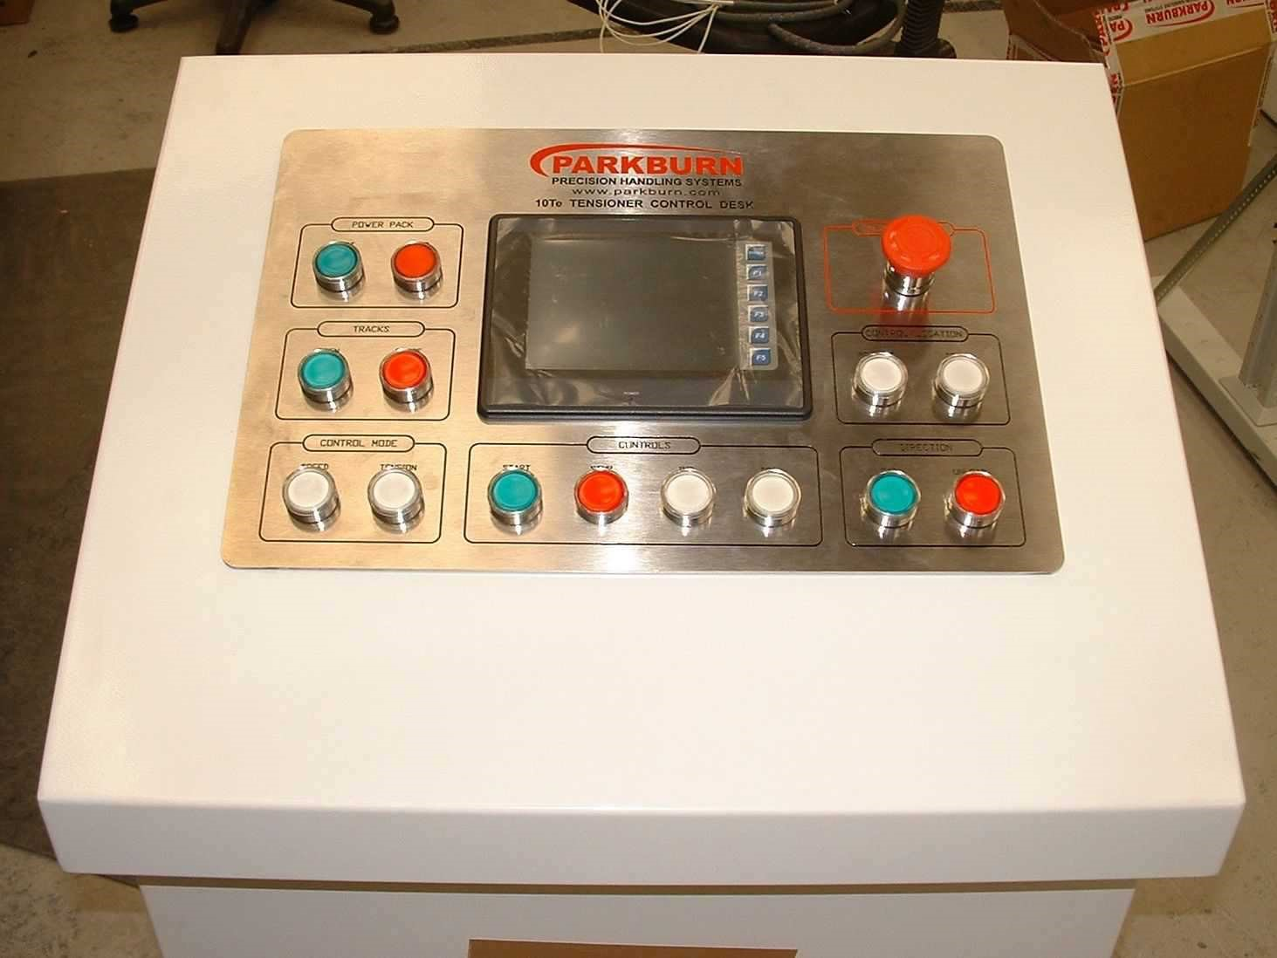

Example 10Te Tensioner Control Console

TECHNICAL AND MANUFACTURING STANDARDS

Design & HSE Standards
The following rules will, where applicable, be used as guidelines for design and manufacture of the system;
- DNV Standard for Certification No 2.22 lifting Appliances - 2013
- DNV Rules for the Classification of Ships - 2012
- DNV Rules for the Planning and Execution of Marine Operations Jan 1996. • The complete drive and control system as standard is designed and built in accordance with EN 60204-1 Safety of machinery - Electrical equipment of machines.
- The Supply of Machinery (Safety) Regulations 1992
Other areas of the system will be designed using good engineering practice and principles
It is currently understood that the equipment specified above (excluding including all lift points) will not be subject to any class design / manufacture or test verification requirement.

Example Manufacturing Standards
BS EN 10025-2: 2004 | Hot rolled products of non-alloy structural steels. Technical delivery conditions
BS EN ISO 15614-1: 2004 +A4: 2012 | Specification and approval of welding procedures for metallic materials. Arc welding of steel
BS EN 287-1: 2004 | Approval testing of welders for fusion welding steels
BS EN 9001: 2008 | Quality systems
SOLAS 2011 | International convention for safety at sea
Institution of Electrical  Engineers | Recommendations for the electrical and electronic equipment aboard mobile and fixed offshore installations.
IEC 60092 | Electrical Installations in Ships
IEE 6th Edition | Electrical and Electronic Equipment on-board ships
BS EN 12385-1: 2002 + A1: 2008 | Specification for ropes
BS EN 10083-1:2006  BS EN 10083-2:2006 | Specification for quenched and tempered steels
ISO | Metric system

