
Modular Offshore Turntable
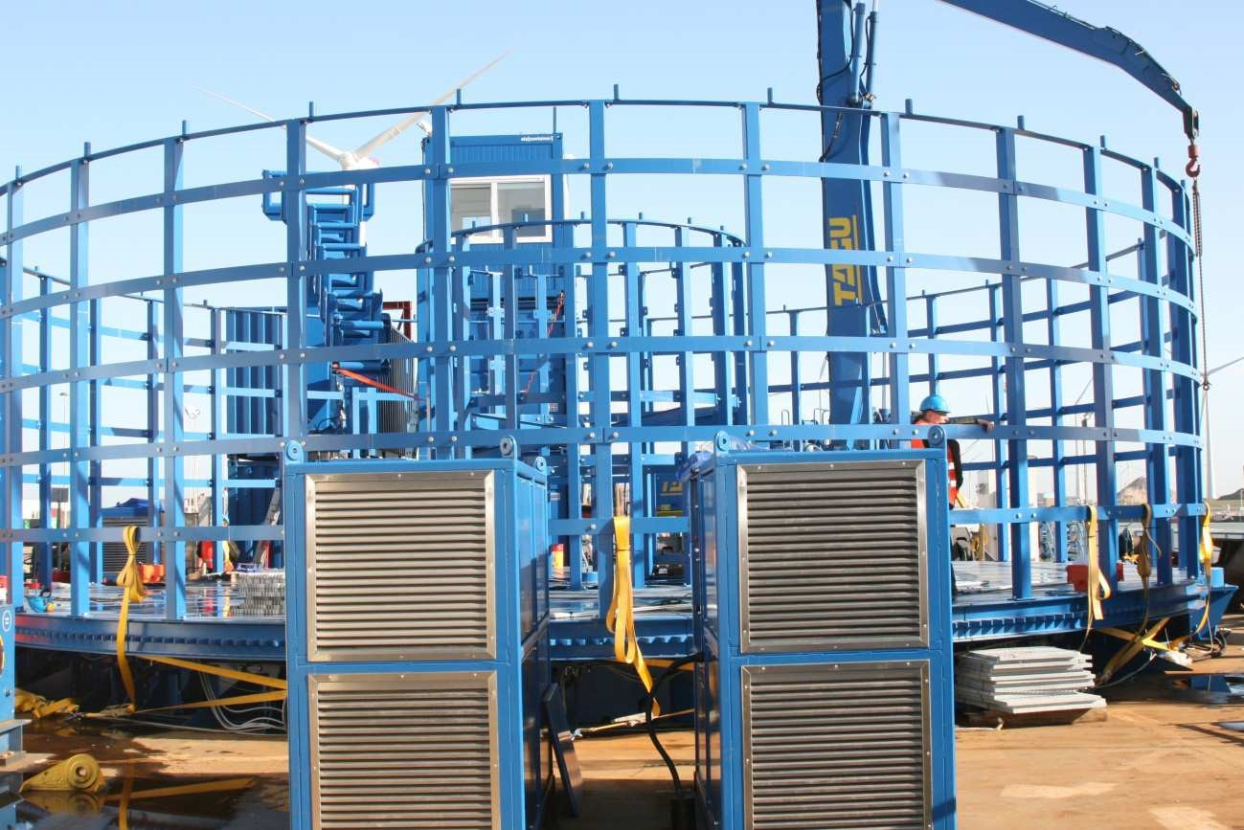

Technical Specification
Turntable construction | ln accordance with existing HICE-design (DNV-GL design-approval)
Turntable construction | Foundation c/w 2 tracks of loadbearing wheels (h=508 mm)  Track 1 with diameter 6,640 mm and surface 26 m²  Track 2 with diameter 11,520 mm and surface 40 m²  Track 1 contains 18 pcs loadbearing wheels in hinged carrier  Track 2 contains 36 pcs loadbearing wheels in hinged carrier  Foundation c/w 2 tracks of loadbearing wheels (h=508 mm)
Turntable construction | Central bearing connected by star-frame to track 1/2  Turntable deck consisting of 18 segments, 6mm steel plated Outer/inner walls consisting of 4 m high interconnected SHS120, connected by rolled Bulb-Profile
Dimensions | Outside diameter 14.2 m Inside diameter 4.0 m  Basket internal height 4.0 m  Basket bottom height 0.85 m
Drives | Electro-Hydraulic power unit, 2 x 75 kW, 400 V 50Hz  4 x hydraulic HICE-sprocket drive (50% redundancy) approx. 20 kW with fixed ring gear on turntable deck HPU can be operated separately
Coating | 1 x primer ‘jotun’ 0.150 mm  1 x topcoat ‘jotun’ 0.050 mm RAL 5010 blue

General Arrangement
General information
HICE lifting system | hydraulic compensation system with 40 mm strake lifting the Turntable deck from 0 mm (fixed, non-rotating) to + 40 mm (maximum strake, rotating) by means of 54 cylinders (stainless rod) divided over 6- sections
Weight/Capacity | Mass (empty) approx. 100 t (depends on final lay out) Carrying capacity 1,000 t
Load bearing wheels | 54 pcs cast iron wheel 400 mm diameter bearing capacity 20.5 t/wheel
Load distribution | the static Uniform Distributed Load (UDL) generated through the 2 foundation track with the turntable loaded to maximum capacity is approx. 12 t/m² The foundation tracks are 1.2 m wide with a combined surface of approx. 71 m²
General: | DDNV-GL certified

Performance Data
Modular Offshore Turntable
Rotational speed | 1,200 m/hour at centre core (ID)
Electrical requirements | 400V/50Hz power supply included
Parking brake | 20 seconds from 0 - max.
Accelerations with full load | 20 seconds from max. to 0
Braking with full load | 10 seconds from max. to 0
Fast Stop Braking with full load | <5 seconds from max. to 0
Emergency Stop Braking with full load | 1,200 m/hour at centre core (ID)

Turntable Basement
