

Carousel 4750T/7000T

Carousel – 4750 Ton Configuration

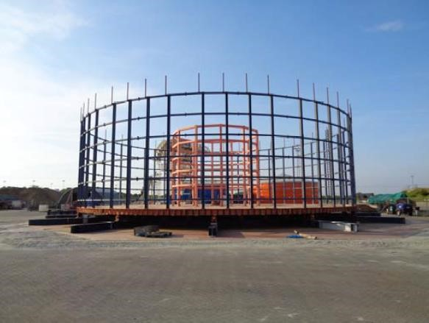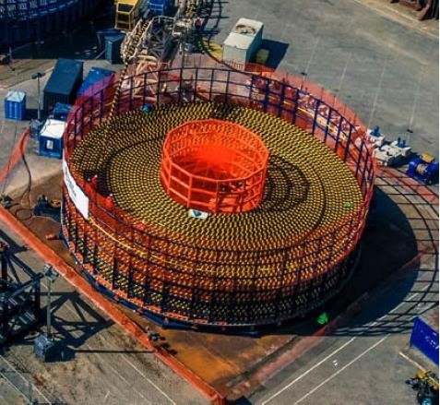

Technical Specifications:
Dimensions | Outer Diameter : 23.0m  Inner Diameter : 6.0m / 8.0m Height : 6.6m
Capacity | 4750 Tons
Weight | 211.3 Tons
Speed | 1000m/hour maximum lay rate
Drive | 2 x 160kW Hydraulic motors equipped with Failsafe Brakes
Required Power | 440/400V, 60Hz/50Hz, 3 Phase
Design Verification/Certification | Lloyd’s Register
Controls | Remote Central Control

Other Information
Designed / Manufactured | Made in Netherlands
Year of Built | 2018
Current Location | Netherlands
Ownership | Advanced Submarine Networks Pte Ltd (the carousel was previously owned by Dutch Offshore Contractors)

Advanced Submarine Networks Pte Ltd
Cendex Centre, 120 Lower Delta Road #10-10 Singapore 169208, Tel: +65-62610840

Carousel - 7000 Ton Configuration

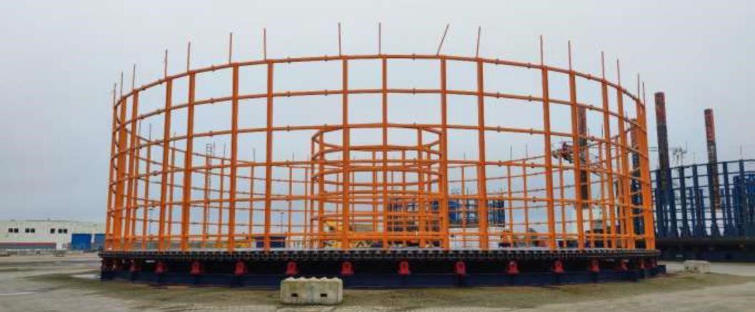
Technical Specifications:
Dimensions | Outer Diameter : 28.0m  Inner Diameter : 6.0m / 8.0m Height : 6.6m
Capacity | 7000 Tons
Weight | 225 Tons
Speed | 1000m/hour maximum lay rate
Drive | 2/4 x 160kW Hydraulic motors equipped with Failsafe Brakes
Required Power | 440/400V, 60Hz/50Hz, 3 Phase
Design Verification | Lloyd’s Register
Controls | Remote Central Control

Other Information
Designed / Manufactured | Made in the Netherlands
Year of Built | 2018
Current Location | Netherlands
Ownership | Advanced Submarine Networks Pte Ltd (the carousel was previously owned by Dutch Offshore Contractors)
Contact | Please contact us: d.khaled@submmarine-networks.com

Advanced Submarine Networks Pte Ltd
Cendex Centre, 120 Lower Delta Road #10-10 Singapore 169208, Tel: +65-62610840

